Question 01.

package Question01;

public class **List** {

private Student[] data;

private int size;

private int capacity;

public List(int capacity) {

this.capacity = capacity;

this.data = new Student[capacity];

this.size = 0;

}

public void add(Student student) {

if (size < capacity) {

data[size++] = student;

} else {

System.out.println("List is full. Cannot add student.");

}

}

public void display() {

if (size == 0) {

System.out.println("List is empty.");

return;

}

System.out.printf("%-15s %-15s %-8s %-5s\n", "Student Number", "Name", "Gender", "Grade");

System.out.println("---------------------------------------------------");

for (int i = 0; i < size; i++) {

System.out.printf("%-15s %-15s %-8c %-5s\n",

data[i].getStudentNumber(), data[i].getName(),

data[i].getGender(), data[i].getGrade());

}

}

public boolean isEmpty() {

return size == 0;

}

public int listSize() {

return size;

}

public Student retrieveList(int index) {

if (index >= 0 && index < size) {

return data[index];

}

return null;

}

public void sortByGrade() {

for (int i = 0; i < size - 1; i++) {

int minIndex = i;

for (int j = i + 1; j < size; j++) {

if (data[j].getGrade().compareTo(data[minIndex].getGrade()) < 0) {

minIndex = j;

}

}

Student temp = data[minIndex];

data[minIndex] = data[i];

data[i] = temp;

}

}

public List findStudentsByGradeBinary(String targetGrade) {

List resultList = new List(this.size);

int low = 0;

int high = size - 1;

int initialMatchIndex = -1;

while (low <= high) {

int mid = low + (high - low) / 2;

int comparison = data[mid].getGrade().compareTo(targetGrade);

if (comparison == 0) {

initialMatchIndex = mid;

break;

} else if (comparison < 0) {

low = mid + 1;

} else {

high = mid - 1;

}

}

if (initialMatchIndex != -1) {

resultList.add(data[initialMatchIndex]);

int tempIndex = initialMatchIndex - 1;

while (tempIndex >= 0 && data[tempIndex].getGrade().equals(targetGrade)) {

resultList.add(data[tempIndex]);

tempIndex--;

}

tempIndex = initialMatchIndex + 1;

while (tempIndex < size && data[tempIndex].getGrade().equals(targetGrade)) {

resultList.add(data[tempIndex]);

tempIndex++;

}

}

return resultList;

}

public List findStudentsByGradeSequential(String targetGrade) {

List resultList = new List(this.size);

for (int i = 0; i < size; i++) {

if (data[i].getGrade().equals(targetGrade)) {

resultList.add(data[i]);

}

}

return resultList;

}

}

package Question01;

public class **Student** {

String studentNo;

String name;

char gender;

char grade;

public Student(String studentNo, String name, char gender, char grade) {

this.studentNo = studentNo;

this.name = name;

this.gender = gender;

this.grade = grade;

}

public String getStudentNumber() {

return studentNo;

}

public String getName() {

return name;

}

public char getGender() {

return gender;

}

public String getGrade() {

return String.valueOf(grade);

}

public void setGrade(char grade) {

this.grade = grade;

}

public void setGrade(String grade) {

if (grade != null && grade.length() == 1) {

this.grade = grade.charAt(0);

} else {

System.err.println("Invalid grade format: " + grade);

}

}

@Override

public String toString() {

return "Student{" +

"studentNo='" + studentNo + '\'' +

", name='" + name + '\'' +

", gender=" + gender +

", grade=" + grade +

'}';

}

}

package Question01;

public class **MainApp** {

public static void main(String[] args) {

List studentDetails = new List(10);

studentDetails.add(new Student("PS/2017/016", "Amal", 'M', 'A'));

studentDetails.add(new Student("PS/2017/198", "Binura", 'M', 'A'));

studentDetails.add(new Student("PS/2017/301", "Chanaka", 'M', 'A'));

studentDetails.add(new Student("PS/2017/045", "Sarath", 'M', 'B'));

studentDetails.add(new Student("PS/2017/149", "Nirmala", 'F', 'B'));

studentDetails.add(new Student("PS/2017/151", "Sithara", 'F', 'B'));

studentDetails.add(new Student("PS/2017/280", "Kamal", 'M', 'B'));

studentDetails.add(new Student("PS/2017/273", "Kasuni", 'F', 'C'));

studentDetails.add(new Student("PS/2017/312", "Akila", 'F', 'C'));

studentDetails.add(new Student("PS/2017/105", "Dasuni", 'F', 'D'));

System.out.println("All Student Details:");

studentDetails.display();

System.out.println("\n---------------------------------------------------\n");

System.out.println("Students with Grade 'B' (Sequential Search):");

List studentsWithGradeBSeq = studentDetails.findStudentsByGradeSequential("B");

studentsWithGradeBSeq.display();

System.out.println("\n---------------------------------------------------\n");

System.out.println("Students with Grade 'A' (Sequential Search):");

List studentsWithGradeASeq = studentDetails.findStudentsByGradeSequential("A");

studentsWithGradeASeq.display();

System.out.println("\n---------------------------------------------------\n");

studentDetails.sortByGrade();

System.out.println("Student details after sorting by grade (for Binary Search):");

studentDetails.display();

System.out.println("\n---------------------------------------------------\n");

System.out.println("Students with Grade 'B' (Binary Search after sorting):");

List studentsWithGradeBBin = studentDetails.findStudentsByGradeBinary("B");

studentsWithGradeBBin.display();

System.out.println("\n---------------------------------------------------\n");

System.out.println("Students with Grade 'A' (Binary Search after sorting):");

List studentsWithGradeABin = studentDetails.findStudentsByGradeBinary("A");

studentsWithGradeABin.display();

System.out.println("\n---------------------------------------------------\n");

System.out.println("Students with Grade 'D' (Binary Search after sorting):");

List studentsWithGradeDBin = studentDetails.findStudentsByGradeBinary("D");

studentsWithGradeDBin.display();

System.out.println("\n---------------------------------------------------\n");

System.out.println("Students with Grade 'C' (Sequential Search - original list order):");

List studentsWithGradeCSeq = studentDetails.findStudentsByGradeSequential("C");

studentsWithGradeCSeq.display();

System.out.println("\n---------------------------------------------------\n");

System.out.println("Students with Grade 'C' (Binary Search - on sorted list):");

List studentsWithGradeCBin = studentDetails.findStudentsByGradeBinary("C");

studentsWithGradeCBin.display();

System.out.println("\n---------------------------------------------------\n");

}

}

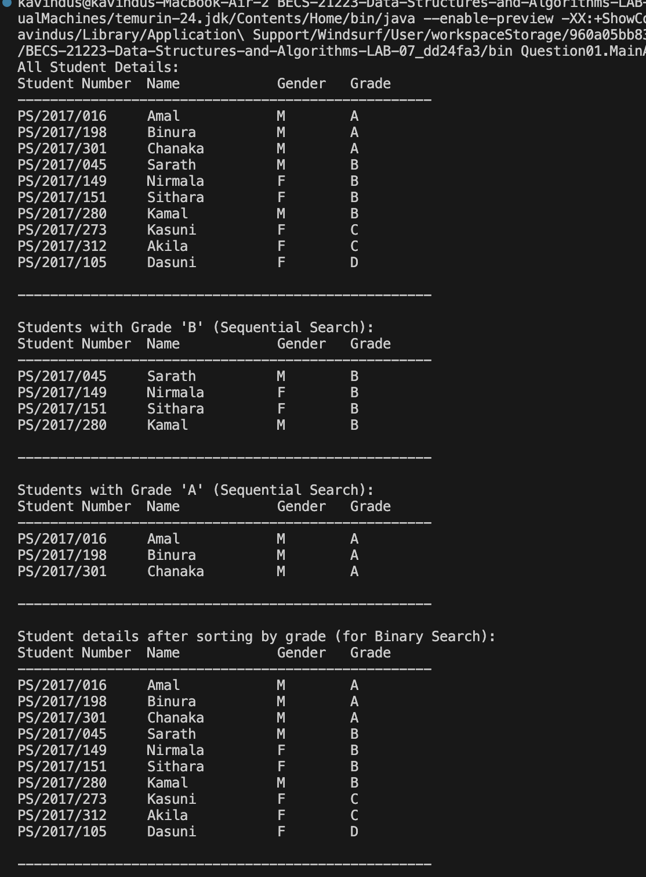

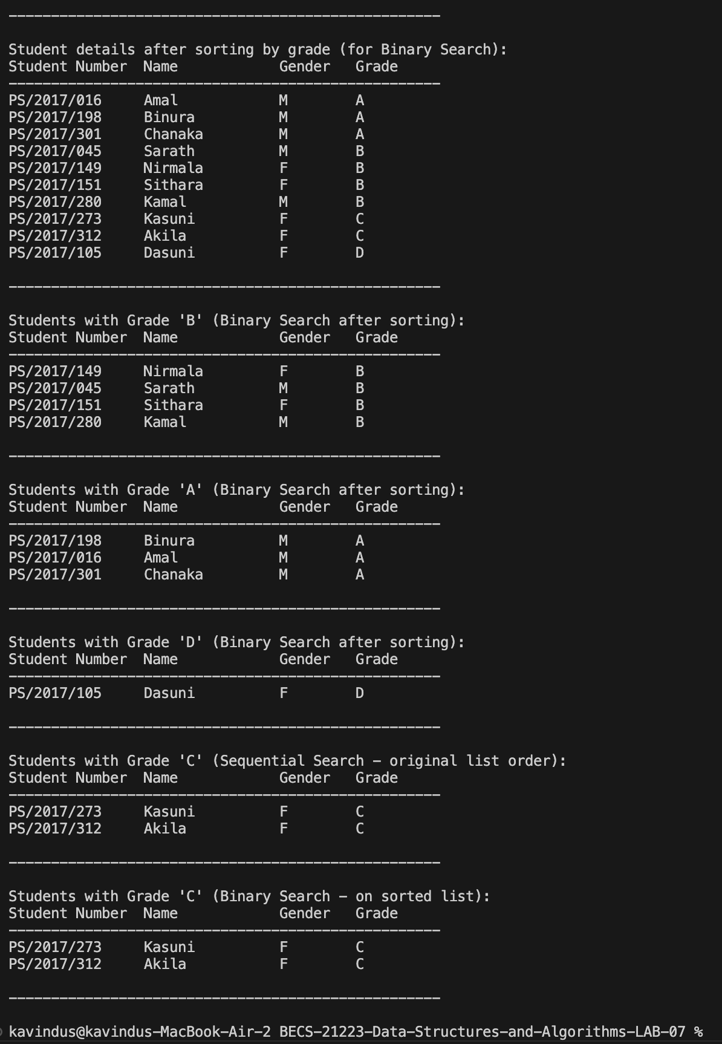

Question 02.

package Question02;

public class **Employee** {

String empId;

String name;

String department;

char grade;

public Employee(String empId, String name, String department, char grade) {

this.empId = empId;

this.name = name;

this.department = department;

this.grade = grade;

}

public String getEmpId() {

return empId;

}

public String getName() {

return name;

}

public String getDepartment() {

return department;

}

public String getGrade() {

return String.valueOf(grade);

}

}

package Question02;

public class **LinkedList** {

private Node head;

private int size;

private class Node {

Employee data;

Node next;

Node(Employee data) {

this.data = data;

this.next = null;

}

}

public void add(Employee employee) {

Node newNode = new Node(employee);

if (head == null) {

head = newNode;

} else {

Node current = head;

while (current.next != null) {

current = current.next;

}

current.next = newNode;

}

size++;

}

public void display() {

if (head == null) {

System.out.println("List is empty.");

return;

}

System.out.printf("%-10s %-15s %-15s %-6s\n", "Employee ID", "Name", "Department", "Grade");

System.out.println("--------------------------------------------------------");

Node current = head;

while (current != null) {

System.out.printf("%-10s %-15s %-15s %-6s\n",

current.data.getEmpId(), current.data.getName(),

current.data.getDepartment(), current.data.getGrade());

current = current.next;

}

}

public void insertionSortByGrade() {

if (head == null || head.next == null) {

return;

}

Node sorted = null;

Node current = head;

while (current != null) {

Node next = current.next;

if (sorted == null || sorted.data.getGrade().compareTo(current.data.getGrade()) > 0) {

current.next = sorted;

sorted = current;

} else {

Node temp = sorted;

while (temp.next != null &&

temp.next.data.getGrade().compareTo(current.data.getGrade()) <= 0) {

temp = temp.next;

}

current.next = temp.next;

temp.next = current;

}

current = next;

}

head = sorted;

}

public LinkedList findEmployeesByGrade(String targetGrade) {

LinkedList resultList = new LinkedList();

Node current = head;

while (current != null) {

if (current.data.getGrade().equals(targetGrade)) {

resultList.add(current.data);

}

current = current.next;

}

return resultList;

}

}

package Question02;

public class **List** {

private Employee[] data;

private int size;

private int capacity;

public List(int capacity) {

this.capacity = capacity;

this.data = new Employee[capacity];

this.size = 0;

}

public void add(Employee employee) {

if (size < capacity) {

data[size++] = employee;

} else {

System.out.println("List is full. Cannot add employee.");

}

}

public void display() {

if (size == 0) {

System.out.println("List is empty.");

return;

}

System.out.printf("%-10s %-15s %-15s %-6s\n", "Employee ID", "Name", "Department", "Grade");

System.out.println("--------------------------------------------------------");

for (int i = 0; i < size; i++) {

System.out.printf("%-10s %-15s %-15s %-6s\n",

data[i].getEmpId(), data[i].getName(),

data[i].getDepartment(), data[i].getGrade());

}

}

public void insertionSortByGrade() {

for (int i = 1; i < size; i++) {

Employee key = data[i];

int j = i - 1;

while (j >= 0 && data[j].getGrade().compareTo(key.getGrade()) > 0) {

data[j + 1] = data[j];

j = j - 1;

}

data[j + 1] = key;

}

}

public List findEmployeesByGradeBinary(String targetGrade) {

List resultList = new List(this.size);

int low = 0;

int high = size - 1;

int initialMatchIndex = -1;

while (low <= high) {

int mid = low + (high - low) / 2;

int comparison = data[mid].getGrade().compareTo(targetGrade);

if (comparison == 0) {

initialMatchIndex = mid;

break;

} else if (comparison < 0) {

low = mid + 1;

} else {

high = mid - 1;

}

}

if (initialMatchIndex != -1) {

resultList.add(data[initialMatchIndex]);

int tempIndex = initialMatchIndex - 1;

while (tempIndex >= 0 && data[tempIndex].getGrade().equals(targetGrade)) {

resultList.add(data[tempIndex]);

tempIndex--;

}

tempIndex = initialMatchIndex + 1;

while (tempIndex < size && data[tempIndex].getGrade().equals(targetGrade)) {

resultList.add(data[tempIndex]);

tempIndex++;

}

}

return resultList;

}

}

package Question02;

public class **MainApp** {

public static void main(String[] args) {

// Array implementation

System.out.println("Array Implementation:");

System.out.println("=====================\n");

List employeeList = new List(10);

employeeList.add(new Employee("EMP001", "Anjali", "HR", 'B'));

employeeList.add(new Employee("EMP002", "Roshan", "Finance", 'A'));

employeeList.add(new Employee("EMP003", "Meera", "IT", 'C'));

employeeList.add(new Employee("EMP004", "Hiran", "HR", 'A'));

employeeList.add(new Employee("EMP005", "Sanjay", "Marketing", 'B'));

employeeList.add(new Employee("EMP006", "Vimukthi", "Finance", 'D'));

employeeList.add(new Employee("EMP007", "Dilani", "IT", 'C'));

employeeList.add(new Employee("EMP008", "Tharindu", "Marketing", 'A'));

employeeList.add(new Employee("EMP009", "Ishara", "HR", 'B'));

employeeList.add(new Employee("EMP010", "Lahiru", "IT", 'D'));

System.out.println("All Employee Details:");

employeeList.display();

System.out.println("\n---------------------------------------------------\n");

System.out.println("Sorting by Grade (Insertion Sort on Array):");

employeeList.insertionSortByGrade();

employeeList.display();

System.out.println("\n---------------------------------------------------\n");

System.out.println("Employees with Grade 'B' (Binary Search on sorted array):");

List gradeBEmployees = employeeList.findEmployeesByGradeBinary("B");

gradeBEmployees.display();

System.out.println("\n---------------------------------------------------\n");

// Linked List implementation

System.out.println("Linked List Implementation:");

System.out.println("==========================\n");

LinkedList employeeLinkedList = new LinkedList();

employeeLinkedList.add(new Employee("EMP001", "Anjali", "HR", 'B'));

employeeLinkedList.add(new Employee("EMP002", "Roshan", "Finance", 'A'));

employeeLinkedList.add(new Employee("EMP003", "Meera", "IT", 'C'));

employeeLinkedList.add(new Employee("EMP004", "Hiran", "HR", 'A'));

employeeLinkedList.add(new Employee("EMP005", "Sanjay", "Marketing", 'B'));

employeeLinkedList.add(new Employee("EMP006", "Vimukthi", "Finance", 'D'));

employeeLinkedList.add(new Employee("EMP007", "Dilani", "IT", 'C'));

employeeLinkedList.add(new Employee("EMP008", "Tharindu", "Marketing", 'A'));

employeeLinkedList.add(new Employee("EMP009", "Ishara", "HR", 'B'));

employeeLinkedList.add(new Employee("EMP010", "Lahiru", "IT", 'D'));

System.out.println("All Employee Details:");

employeeLinkedList.display();

System.out.println("\n---------------------------------------------------\n");

System.out.println("Sorting by Grade (Insertion Sort on Linked List):");

employeeLinkedList.insertionSortByGrade();

employeeLinkedList.display();

System.out.println("\n---------------------------------------------------\n");

System.out.println("Employees with Grade 'A' (Search on linked list):");

LinkedList gradeAEmployees = employeeLinkedList.findEmployeesByGrade("A");

gradeAEmployees.display();

}

}

